|  |  |  |  |
| --- | --- | --- | --- |
| **F:\Learning bugs\Foundation Subjects\Dolly the Fly - Science.jpgLyng Primary School Knowledge Organiser** | | | |
| **Topic:** | **Forces and space: Earth and space** | Year 5 | Spring 1 |

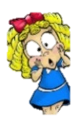

**What should I already know?**

Children should have some knowledge of Earth and Space including information about:

* Stars and the sun
* The seasons
* Day and night
* The moon
* The planets
* The Solar System

**Notable scientists**

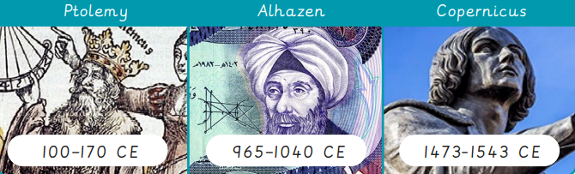

Ptolemy – 100 – 170 CE

Alhazen 965 – 1040 CE

Copernicus 1473 – 1543 CE

|  |  |
| --- | --- |
| **What Step On and Goldilocks words will I use?** | |
| **Spelling** | **Definition** |
| artificial satellite | A human – made object that orbits a planet. |
| axis | The imaginary line that Earth spins around, going from the North Pole to the South Pole. |
| calibrate | To adjust a device so that it measures accurately. |
| celestial bodies | Natural objects in space, such as planets, moons and stars. |
| elliptical | Shaped like an oval, not a perfect circle. |
| geocentric | Having the earth at its centre. |
| gnomon | The part of a sundial that sticks up and casts a shadow on the face of the dial to indicate the time. |
| gravity | A force that pulls things towards each other. |
| heliocentric | Having the sun at its centre. |
| horizon | The line at which the Earth’s surface and the sky appear to meet. |
| last quarter moon | The phase when the Moon appears like half a circle, with the left side illuminated. |
| natural satellite | A natural object that orbits a planet, like a moon. |
| orbit | The path that a planet or other celestial body takes as it moves around a star. |
| sundial | An outdoor device that uses the Sun’s position to show the time of day. |

|  |
| --- |
| **Investigate!** |
| * Different models of how the Solar System is represented. * Creating a human model of the Solar System. * Investigate the phases of the Moon. * Create a model to show day and night. * Create a sundial to show the movement of the sun throughout the day. |

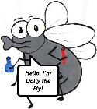

**What will I know by the end of the unit?**

|  |  |
| --- | --- |
|  | |
| How do we represent the Solar System? | Describe the geocentric model  Describe the heliocentric model  Describe the shape of celestial bodies. |
| How do celestial bodies move around the Solar System? | Name the celestial bodies in the solar system.  Name the force that keeps planets in their orbits.  Describe the orbits of celestial bodies in the Solar System |
| What do we know about the moon? | Define the term ‘moon’.  Name some of the phases of the Moon.  Describe the orbit of the Moon around the Earth. |
| Why do we have day and night? | Describe how the Earth rotates on its axis.  Describe the tilt of the Earth.  Describe the orbit of the Earth around the Sun. |
| How do we measure time without a clock? | Name parts of the sundial.  Explain how a sundial works  Calibrate a sundial using a compass and torch.  Use a sundial to measure time. |
| What is a satellite? | List some of the uses of satellites.  Explain why space junk poses a problem to satellites.  Analyse patterns in temperature data for the Earth. |

|  |  |  |  |
| --- | --- | --- | --- |
| **F:\Learning bugs\Foundation Subjects\Dolly the Fly - Science.jpgLyng Primary School Knowledge Organiser** | | | |
| **Topic:** | **Science** | Year 5  *Earth and Space* | Spring 1 |

|  |  |  |  |
| --- | --- | --- | --- |
| 1. What does ‘geocentric’ mean? | **S** | | **E** |
| 1. Move around the Sun |  |  | |
| 1. Move around the Moon |  |  | |
| 1. Move around the Earth |  |  | |
|  |  |  | |

|  |  |  |
| --- | --- | --- |
| 5. The Earth tilts on its axis. | **S** | **E** |
| 1. True |  |  |
| 1. False |  |  |
|  |  |  |
|  |  |  |

|  |  |
| --- | --- |
| 6. Can you describe how a sundial works? | |
| **S** | **E** |
|  |  |

|  |  |  |
| --- | --- | --- |
| 2. Which planet has the shortest orbit around the Sun? | **S** | **E** |
| 1. Mars |  |  |
| 1. Mercury |  |  |
| 1. Jupiter |  |  |
|  |  |  |

|  |  |  |
| --- | --- | --- |
| 3. Which planet does not have a moon? | **S** | **E** |
| 1. Mars |  |  |
| 1. Venus |  |  |
| 1. Saturn |  |  |
| 1. Jupiter |  |  |

|  |  |  |
| --- | --- | --- |
| 4. Why is space junk dangerous? | **S** | **E** |
| 1. Could bump into new things such as satellites, space stations or astronauts. |  |  |
| 1. Causes pollution |  |  |
| 1. Looks messy |  |  |